**KABETE NATIONAL POLYTECHNIC**

**SCHOOL OF COMPUTING AND INFORMATICS**

**DIPLOMA IN INFORMATION COMMUNICATION**

**TECHNOLOGY**

**SQITECH INTERNET PROVIDER WEB-BASED**

**MANAGEMENT SYSTEM**

PRESENTED BY:

STUDENT NAME: NJOGU YVONNE WANJIRU

INDEX NO:4060030264

SUPERVISED BY:

MRS…………………………………………………….

**PROJECT SUBMITTED TO THE KENYA NATIONAL EXAMINATION COUNCIL IN PARTIAL FULFILMENT FOR THE DIPLOMA IN INFORMATION COMMUNICATION TECHNOLOGY**

SUBMISSION DATE:

**DEDICATION.**

This project is dedicated to my parents and guardians for their financial support during the preparation of this project. May the Almighty Lord bless us all abundantly and bring success to our project.

**ACKNOWLEDGEMENT.**

I acknowledge the Lord Almighty for his goodness and mercies that have enabled me to reach where I am. I also acknowledge my parents, family and friends for their financial and moral support.

## SQITECH INTERNET SERVICE PROVIDER WEB-BASED SYSTEM

## ABSTRACT

A **web-based system** is a software application that runs on a web server and is accessed through a web browser using the internet. It is used to provide information used during decision making processes and control analysis. The main objective of developing the web-based system Capture customer Details and to Automate billing based on data usage. The aim of developing the system was to develop a robust Sqitech ISP web-based system that streamlines the management of internet services while enhancing customer experience and satisfaction.

The specific objectives of Sqitech Internet Service Provider Web-Based System are: To Capture customer Details, to automate billing based on data usage, To Integrate a support module for handling service requests, To Secure sensitive customer data.

The spiral model will be adopted as the development methodology due to its iterative nature which allows continuous refinement of system features based on user feedback. It focuses on collaboration, customer feedback, and incremental progress to ensure continuous improvement. Incremental methodology was also preferred since the system is built and delivered in **small and manageable parts** (increments) **adding functionality** to the system until the final product is complete. Each phase of both methodologies was completed before continuation to the next phase of development.

The methods of fact finding and data collection used during the study were interviews, Document review & analysis, Questionnaires & survey and **Case Studies & Competitor Analysis. System analysis for the new system was done to get a way to computerize data collection methods and establish ways to access data quicker and more efficiently.**

The system will be developed using React.js for interactive frontend design and the backend shall be designed using Node.js. The system will also use MySQL for structured data storage. System testing will involve unit testing, integration testing and user acceptance testing to ensure functionality, security and usability before deployment.

SQITECH INTERNET SERVICE PROVIDER WEB-BASED SYSTEM 3

ABSTRACT 3

CHAPTER ONE: INTRODUCTION 4

1.1 Introduction of the project area 4

Background of the Study, Overview of existing system, Overview of the proposed system, Problem Statement, Objectives, Research Questions, Justification, Scope of the Study, Limitations of the proposed system, Project Risk and Mitigation, Project Schedule 4

1.2 Background of the Study 4

1.2.2 Overview of existing system: 8

1.2.3 Overview of the proposed system: 8

1.3 Problem Statement 8

1.5 Research Questions 9

1.6 Justification 9

1.7 Scope of the Study 10

1.8 CHALLENGES WHEN DEVELOPING THE SYSTEM. 10

1.9 Project Schedule 11

This chapter has the following; literature reading of the project, challenges of the current system, reviewed similar systems, gaps in the existing system and methodology used in the revised system. 12

1. Planning Phase (Requirement Analysis and Feasibility Study) 13

2. Risk Analysis & Prototyping 13

3. Development & Testing (Implementation Phase) 14

*1.* Risk Analysis Phase 17

*2.* System Design & Development Phase 17

*3.* Testing & Evaluation Phase 17

1. Technical Feasibility 18

1. Entity Relationship Diagram (ERD) 25

2. Flowcharts 25

Benefits of the 3NF Design 28

SERVICE_PLAN Entity Life History 32

CUSTOMER REPORT – *Customer List Screen* 41

SERVICE PLAN REPORT – *Service Plan List Screen* 41

BILLING REPORT – *Billing History Screen* 42

PAYMENT REPORT – *Payment History Screen* 42

SUPPORT TICKET REPORT – *Customer Support Tickets Screen* 43

CUSTOMER TABLE 43

SERVICE PLAN TABLE 43

BILLING TABLE 43

PAYMENT TABLE 44

SUPPORT TICKET TABLE 44

5.0 Overview 47

5.1 Tools Used in the Development 47

5.2 The Platform Used 48

5.3 Proposed Changeover 49

Reasons for Choosing the Parallel Changeover Technique: 49

5.4 Implementation Plan 50

5.5 Methods Used 51

1. System Testing 51

2. Program Testing 51

3. Unit Testing 51

4. Integration Testing 51

5. Acceptance Testing 52

## CHAPTER ONE: INTRODUCTION

## Introduction of the project area

## Background of the Study, Overview of existing system, Overview of the proposed system, Problem Statement, Objectives, Research Questions, Justification**,** Scope of the Study, Limitations of the proposed system, Project Risk and Mitigation, Project Schedule

## 1.2 Background of the Study

With the goal of giving the underprivileged parts of Nairobi region dependable and superior internet service, Sqitech Internet Service Provider was established in 2024. Njogu Yvonne founded the business after realizing the growing need for internet connectivity and the dearth of effective, client-focused service providers in the region. The establishment of Sqitech Internet Service Provider was primarily driven by the goal of closing the digital gap by providing household and commercial clients with dependable and reasonably priced internet solutions. The company sells Internet connecting devices such as Modems, Routers and Internet Cables.

As the company continues to expand, the need for a centralized and automated system to manage customer data, service provisioning, billing, and technical support becomes increasingly urgent. The current manual and fragmented processes cannot keep up with the growing complexity of the operations, leading to inefficiencies, errors, and delays. The growing demand for customer support services has forced the company to hire additional staff, necessitating the need for effective services to ensure that customers receive effective services.

As Sqitech Internet Service Provider has grown, the organizational structure has also evolved. Initially, the company operated with a small team of technicians and customer service representatives. However, with growth, the team has expanded, and the company now has departments focused on various core areas of its operations, including network management, customer service, billing and accounting, marketing, and technical support.

**1.2.1 Organizational Structure**

**ROLES OF THE CEO**

* **Strategic Leadership** – Setting the long-term vision and direction of the Business, ensuring sustainable growth and competitiveness in the market.
* **Business Development** – Identifying new opportunities, partnerships, and innovations to expand services and increase customer base.
* **Financial Oversight** – Managing budgets, revenue streams, and cost control to ensure profitability and financial stability.
* **Regulatory Compliance** – Ensuring the business adheres to government regulations, industry standards, and data protection laws.
* **Operational Efficiency** – Overseeing infrastructure, technology investments, and service quality to maintain a reliable and high-performing network.
* **Customer Experience Management** – Implementing policies that improve customer satisfaction, retention, and service delivery.

**ROLES OF THE NETWORKING DEPARTMENT**

* **Network Monitoring & Performance Optimization** – Continuously monitors network traffic and performance to detect and resolve potential bottlenecks or slowdowns.
* **Network Security & Threat Management** – Implements security protocols such as firewalls, intrusion detection systems (IDS), and encryption to protect against cyber threats and unauthorized access.
* **Troubleshooting & Issue Resolution** – Diagnoses and resolves network outages, connectivity problems, and service disruptions to ensure minimal downtime.
* **Scalability & Upgrades** – Upgrades network capacity and infrastructure to support growing customer demands, ensuring the system can handle increasing traffic loads.
* **IP Address Management** – Assigns and manages public and private IP addresses, ensuring efficient network operation and proper routing.
* **Regulatory Compliance** – Ensures the network follows industry regulations and standards for data protection, lawful interception, and quality of service (QoS).
* **Collaboration with Other Departments** – Works closely with the **Technical Support Team** to assist with troubleshooting customer connectivity issues and the **Billing Department** to track usage-based billing.

**ROLES OF THE NETWORK OPERATIONS.**

* Use network monitoring tools to detect slow speeds, congestion, or potential failures
* Provide first-level troubleshooting and escalate critical issues to engineers if needed.
* Conduct routine maintenance, such as firmware updates and hardware checks.
* Configure routers, switches, and other network devices for optimal performance
* Maintain logs of network performance, incidents, and resolutions for future reference.

**ROLES OF TECHNICAL SUPPORT TEAM**

* Respond to customer complaints about slow internet, connectivity issues, or device configurations.
* Diagnose and resolve basic network issues such as signal loss, high latency, or IP conflicts
* Assist customers with setting up routers, modems, and other networking devices.
* Restart or reconfigure devices remotely to resolve minor issues.
* Educate customers on best practices for internet usage, security, and troubleshooting minor issues.

**ROLES OF SALES, BILLING AND ACCOUNTS DEPARTMENT**

**SALES**

* Develops and implements marketing strategies to increase service subscriptions and upsell add-ons
* Handles new service agreements, renewals, and upgrades
* Advises customers on the best internet plans based on their needs and budget.
* Works with **Billing** team to ensure customers are charged correctly and with **Technical Support** team to address customer inquiries.

**BILLING**

* Creates and sends monthly or usage-based bills to customers
* Ensures customers are charged correctly based on their subscribed internet plan and data consumption.
* Manages payment transactions through various channels (bank transfers, mobile money, credit/debit cards).
* Provides revenue reports to the **Accounts Department** for financial tracking.

**ACCOUNTS**

* Allocates financial resources for infrastructure upgrades, salaries, marketing, and other operational needs.
* Prepares profit/loss statements, balance sheets, and financial forecasts for management.
* Ensures all financial records are in line with tax laws and industry regulations.
* Tracks income from customer payments and manages company expenses.

**ROLES OF CUSTOMER SERVICE TEAM**

* Assists customers with questions about internet plans, pricing, and service availability
* Listens to customer complaints regarding **service disruptions, billing errors, or poor internet speed**
* Assists customers with account registration, upgrades, and cancellations**.**
* Guides users through plan changes, contract renewals, and data top-ups
* Collects customer feedback to identify common issues and areas for service improvement.
* Educates users on **cybersecurity best practices, such as password protection.**

## 1.2.2 Overview of existing system:

In Sqitech Internet Provider new customers sign up manually via phone calls and emails. Customer details are recorded manually on spreadsheets and basic databases which makes the process prone to errors and customer details easily accessible by unauthorised personnel. Technicians configure routers and access points manually. Customers usually report issues via phone calls hence technicians have to visit customer’s locations for troubleshooting. It consumes a lot of time, has limited scalability since it is difficult to manage customer base growth. It has delayed response time as it takes longer to diagnose network issues and fix them.

### Overview of the proposed system:

The proposed **system** aims to streamline service management, automate billing processes, and enhance customer experience. It will provide a centralized online platform where customers can manage their accounts, make payments, order new services, and receive support efficiently. The system will integrate various functionalities, including user account management, automated billing, online service purchases, and real-time customer support, ensuring seamless interaction between the ISP and its clients.

Through the system, customers may register and manage their subscriptions, keep an eye on their network connection and change their account details.

The system will generate automated monthly invoices based on the customer's selected internet plan. Customers will receive notifications about upcoming payments via email or SMS. Multiple payment options, including credit/debit cards, mobile money, and bank transfers, will be available for convenience. Once a payment is made, the system will instantly update the customer's account and generate a digital receipt. Late payment reminders and automated service suspensions for overdue accounts will also be implemented to ensure timely revenue collection.

## Problem Statement

The traditional methods of managing internet service provisioning often lead to inefficiencies and customer dissatisfaction. Several critical issues have been identified: Manual entries in customer and billing databases increasing errors, Fragmented systems may result in delayed or incorrect billing, Slow responses to service issues due to poor data access hinder customer support, managing vast data without integration reduces system efficiency

* 1. **AIM**

To develop a robust Sqitech ISP that streamlines the management of internet services while enhancing customer experience and satisfaction

**1.4.1 General Objectives**

1. Carry out a feasibility study on the operation of how the Internet service provider manual system operates.
2. Analyse and prioritize requirements to ensure they are clear, complete and feasible. For the system
3. Create a detailed design specification, including data models, interface and system architecture for the system
4. Write the actual code for the system to be implemented and test individual components to ensure they work correctly
5. Test the combined components to ensure they function together as expected and the entire system meets the specified requirements. Also conduct testing with end users to validate system meets their expectations.
6. Continuously monitor the system for any issues or areas for improvement. Implement updates and upgrades to improve functionality over time.

**1.4.2 Specific Objectives**

* To Capture customer Details.
* To Automate billing based on rate of data consumption.
* To Integrate a support module for handling service requests.
* To Secure sensitive customer data.

## Research Questions

1. How will the system capture the customer details once they log in to the system?
2. How will billing be automated according to the System?
3. How will the system Integrate a support module for handling service requests?
4. How will the system Secure sensitive customer data?

## **Justification**

The system will improve operational efficiency and streamlines business processes. It will automate tasks like billing, invoicing, and customer support, reducing manual workload and human errors. It will also ensure timely revenue collection and better customer relationship management. Built-in analytics aid strategic decision-making. The system's scalability will support business growth and enhance security measures to protect customer data. Overall, it will optimize costs and contributes to the business long-term success.

The system offers clients with easy access to services, real-time tracking of usage, automated payment reminders, and faster issue resolution. It simplifies navigation, allows for easy upgrades, and provides regular notifications about network maintenance and account status. The system also enhances security and data privacy, protecting customer information from unauthorized access and cyber threats.

## Scope of the Study

Sqitech ISP offers a comprehensive system for ISP sector needs, including customer management, service management, billing and invoicing, customer support, and reporting and analytics. It features a customer registration, profile management, service history tracking, ticketing system, and real-time dashboards for customer satisfaction. This system aims to be accessible 24/7, providing customers with the flexibility to manage their internet services at their convenience

## 1.8 CHALLENGES WHEN DEVELOPING THE SYSTEM.

**Financial Constraints** – Limited budget restricted access to high-end servers, software licenses, and advanced security measures, affecting system efficiency and security.

**Regulatory Compliance** – Ensuring adherence to government regulations and industry standards required additional time and resources, adding complexity to the development process.

**Network Security Risks** – Protecting data from cyber threats like hacking and unauthorized access was challenging due to limited security resources and expertise.

**Limited Technical Expertise** – Gaps in knowledge related to networking protocols, database management, and cybersecurity slowed down development and increased the risk of technical issues.

**Time Constraints** – Strict deadlines pressured the development process, leading to potential compromises in feature completeness, system optimization, and thorough testing.

## **1.9 Project Schedule**

|  |  |  |  |  |  |  |  |
| --- | --- | --- | --- | --- | --- | --- | --- |
|  | | **DURATION** | | | |  |  |
| **JAN 2025** | **FEB 2025** | **MARCH 2025** | **APRIL 2025** | **MAY 2025** | **JUNE 2025** |
| **PHASE** | **TASK** |
| Planning | Define project scope  Feasibility study |  |  |  |  |  |  |
| Designing | Reviews and approve designing  Design database schemes |  |  |  |  |  |  |
| Coding and developing the system | Use of programming language  User interface development |  |  |  |  |  |  |
| Testing | Perform unit testing  Fix issues and retesting |  |  |  |  |  |  |
| Deploying of system and maintenance | Conduct training to users and administrator  Monitor its performance and make updates |  |  |  |  |  |  |
| Documentation | Coding the functional and non-functional requirements of the system, including user needs, business goals, and technical specifications |  |  |  |  |  |  |

CHAPTER TWO: LITERATURE REVIEW

2.0 OVERVIEW

## This chapter has the following; literature reading of the project, challenges of the current system, reviewed similar systems, gaps in the existing system and methodology used in the revised system.

2.1 INTRODUCTION

The increasing demand for reliable internet connectivity has led to the evolution of web-based systems for Internet Service Providers (ISPs). This system streamlines service management, billing and customer support. The system allows customers to manage their accounts, track usage, and make payments online, Automated billing system integrated with various payment gateways will improve the efficiency of subscription management, the system will incorporate cybersecurity features like two-factor authentication and data encryption to protect user information. Challenges such as scalability and cybersecurity threats persist. The organization’s research is still focused on enhancing system resilience and user experience to meet growing digital demands.

2.2 CHALLENGES OF CURRENT SYSTEM

In Sqitech Internet Provider new customers sign up manually via phone calls and emails. Customer details are recorded manually on spreadsheets and basic databases which makes the process prone to errors and customer details easily accessible by unauthorised personnel. Technicians configure routers and access points manually. Customers usually report issues via phone calls hence technicians have to visit customer’s locations for troubleshooting. It consumes a lot of time, has limited scalability since it is difficult to manage customer base growth. It has delayed response time as it takes longer to diagnose network issues and fix them.

2.3 REVIEWED SIMILAR SYSTEMS

**Ultimate back office system** was chosen since it is used for the billing process however it is difficult to implement flexible billing options for individual subscribers. To guarantee proper billing cycles, administrators must carefully modify settings, which can call for more supervision and training. **Zendesk System** is a widely adopted customer service platform to provide internet services but users have identified several limitations such as establishing automation rules and workflows can be intricate often necessitating technical

2.4 GAPS IN EXISTING SYSTEM

The gaps in current system include lack of data back-up and Manual entries in customer and billing databases increasing errors. This problem really interfered and affected the process of generating reports to be used during decision making by the management. Many of the problems will be addressed by the system to avoid errors and ensure customer satisfaction.

2.5 METHODOLOGY FOLLOWED IN REVISED SYSTEM

The **Sqitech Internet Service Provider system** was developed using the **Spiral Model**, a risk-driven approach that allows for continuous refinement of the system through iterative cycles. This model was chosen because Sqitech required flexibility, iterative improvements, and regular feedback integration during development.

The **Spiral Model** consists of four key phases, each repeated in multiple iterations to ensure an efficient and high-quality system. These phases were applied in the development of **Sqitech** as follows:

#### **1. Planning Phase (Requirement Analysis and Feasibility Study)**

In the initial stage, the development team gathered system requirements by engaging with the IT specialists, management, and customers.

* **User needs were identified** customers needed an easy way to pay for services, and track their internet usage.
* **Feasibility was assessed** ensuring that the system could handle large data volumes and provide real-time interactions.
* **Risk analysis was conducted**, identifying possible challenges such as security vulnerabilities, system scalability, and user adoption issues.

#### **2. Risk Analysis & Prototyping**

Once requirements were gathered, the team created a **prototype** to test the core functionality before full-scale development.

* The **first prototype** included **basic features** such as user registration, Billing.
* It was tested with a small group of users, and **feedback was collected** to identify usability issues.
* Risks such as **system performance under high traffic** and **data security concerns** were addressed.

#### **3. Development & Testing (Implementation Phase)**

After refining the prototype, the actual system was developed in increments, following multiple iterations of coding and testing.

* The **first iteration** focused on the **customer dashboard** and sign up submission.
* The **second iteration** introduced the **billing system**, allowing the company to bill according to services offered.
* The **third iteration** incorporated **automated notifications and communication features**.
* Each version underwent **unit testing, system testing, and user acceptance testing (UAT)** before moving to the next cycle.

**4.Deployment & Evaluation (User Feedback and Refinements.**

After development and thorough testing, Sqitech was launched in stages.

* **Feedback from users** led to **further refinements**, such as improved filtering options for job searches and an enhanced employer-candidate messaging system.
* Regular system updates were planned, ensuring continuous improvements based on industry trends and user needs.

**CHAPTER THREE: SYSTEM ANALYSIS** **AND METHODOLOGY**

3.0 INTRODUCTION

This chapter has following: Professionals involved in the development, Objectives of the system analysis, Methodology, Feasibility study, Data collection methods, Hardware and software specification

**3.1 PROFESSIONALS INVOLVED IN PROJECT MANAGEGEMENT**.

This are the people involved in the development of the project:

**System Analyst**: Gather and analyse requirements of Sqitech Internet Service Provider Web-Based System, instruct the programmers and collaboratee with other IT specialists to develop the system.

**Project Manager**: Oversee the entire development process, ensure timelines and goals are met and facilitate regular meetings to update stakeholders on progress.

**Programmer/web Developer**: They turn program designs into computer instructions by writing codes to develop different modules in the system such as the authentication of users’ module.

**System Administrator**: Maintain network integrity and the computer systems. The system administrator trains the system users, set up accounts for them, monitor system performance and ensured the system is in accordance to the requirements of the users and the system

**3.2 OBJECTIVES OF SYSTEM ANALYSIS**

1. To ensure the platform is intuitive and easy to navigate for all users
2. To determine the cost of development, hosting, and maintenance
3. To assess the system’s ability to handle multiple concurrent users.
4. To implement security protocols like encryption, multi-factor authentication (MFA), and firewall protection.
5. To gather feedback from potential users to ensure a user-friendly system.
   1. **SYSTEM METHODOLOGY AND TOOLS**

The Spiral Model is a risk-driven software development process that combines iterative development with systematic risk assessment. Sqitech adopts this methodology due to its flexibility, ability to incorporate user feedback at different stages, and its strong emphasis on risk analysis. Since Sqitech is a web-based system with multiple user interactions, the Spiral Model ensures that potential challenges are identified early and mitigated before full-scale deployment. The choice of the Spiral Model for Sqitech is based on the following reasons:

**Risk Management**: The model prioritizes risk assessment, which is essential for ensuring the security and reliability of the system. Iterative Refinement: Continuous iterations allow for incremental improvements, making it easy to incorporate user feedback and system upgrades.

**Iterative Refinement**: Continuous iterations allow for incremental improvements, making it easy to incorporate user feedback and system upgrades.

**Flexibility**: Unlike the Waterfall Model, the Spiral Model allows changes to be made at any stage, ensuring the final product fully meets user expectations.

**Progressive Development**: The system will be built and tested in phases, allowing for early detection and resolution of errors.

The Spiral Model consists of four major phases, which are repeated in iterations until the system is fully developed and ready for deployment.

* **Tools Used:** Requirement documentation tools such as Google Docs, Microsoft Word, and Jira for task management.

#### **Risk Analysis Phase**

* Identify potential risks in Sqitech Internet service provider web-based system such as security vulnerabilities, data privacy concerns, and system performance issues.
* Assess how these risks can be mitigated (e.g., implementing encryption for data security, using cloud backups for data protection).
* Develop prototypes for critical system components to evaluate functionality and performance.
* **Tools Used:** Risk assessment tools like SWOT analysis, flowcharts, and risk matrices.

#### **System Design & Development Phase**

* Design the **user interface (UI)** and **database architecture** of Sqitech Internet service provider web-based system to ensure smooth navigation and efficient data management.
* Choose the appropriate **programming languages and frameworks**:
  + **Front-end:** HTML, CSS (React.js for an interactive user interface).
  + **Back-end:** Node.js for server-side logic.
  + **Database:** MySQL for structured data storage.
* Develop system modules iteratively, testing each component before integrating them into the larger system.

#### **Testing & Evaluation Phase**

* Perform **unit testing** on individual modules and **integration testing** to check system functionality.
* Conduct **user acceptance testing (UAT)** to ensure the system meets employee’s and customer needs.
* Fix any bugs or issues before moving to the next iteration.
* **Tools Used:** Selenium for automated testing, Postman for API testing, and manual user testing feedback.
  1. **FEASIBILITY STUDY**

A **feasibility study** assesses the practicality and viability of developing the **Sqitech Internet Service Provider Web-based system**. This analysis ensures that the system is achievable in terms of cost, technology, and user needs before proceeding with full-scale development. The feasibility study focuses on the following aspects:

### ****Technical Feasibility****

This assesses whether the availabilty of technology will support the development and operation of the Sqitech Internet service provider web-based system.

* **Technology Stack:** The system will be developed using modern web technologies such as **React.js (frontend), Node.js (backend), and MySQL (database)**, all of which are widely used and well-supported.
* **Hosting & Scalability:** The system will be hosted on a **cloud-based server** (Google Cloud) to ensure high availability and scalability.
* **Security Measures:** The system will integrate **SSL encryption, role-based authentication, and secure data storage** to protect user information.
* **Conclusion:** The required technology is available and suitable for developing a **secure, scalable, and user-friendly system**.
  + 1. **Economic Feasibility (Cost-benefit analysis)**

This determines whether the cost of developing and maintaining **Sqitech** is justified by its benefits.

* **Development Costs:** Initial expenses include **web development, domain registration, hosting services, and cybersecurity measures**.
* **Operational Costs:** Includes server maintenance, customer support, and system updates.
* **Conclusion:** The system's long-term financial benefits outweigh the initial costs, making it economically viable.
  + 1. **Operational Feasibility**.

This evaluates whether Sqitech Internet service provider web-based system will be effectively used by the employees.

* **User Adoption:** The system's **user-friendly interface and mobile responsiveness** ensure accessibility for both customers and the customer service team.
* **Training & Support:** Employees and customers will receive **guides, FAQs, and customer support** to help them navigate the system.
* **Integration with Existing Practices:** The system replaces inefficient **manual jobs** while aligning with modern **trends**.
* **Conclusion:** **user adoption is expected to be high**, ensuring operational success.
  1. **Legal Feasibility**

This ensures Sqitech Internet service provider web-based system complies with labour laws, data protection regulations, and business policies.

* **Data Protection & Privacy:** **Sqitech** will follow **GDPR and local data protection laws** tosafeguard user information**.**
* **Terms & Conditions:** The system will include **clear usage policies for employees and customers**.
* **Conclusion:** The system is legally compliant as long as privacy policies and employment laws are strictly followed.
  1. **Schedule Feasibility**

This assesses whether the project can be completed within a reasonable timeframe.

* **Development Timeline:** The project will follow a **structured development schedule** based on the **Spiral Model**, ensuring timely delivery.
* **Prototype Development:** A **minimum viable product (MVP)** will be developed within **2–3 months** to test core functionalities.
* **Testing & Deployment:** System testing and user feedback incorporation will take **1–2 months**, followed by a full launch.
* **Conclusion:** The project timeline is realistic and achievable, ensuring **on-time delivery without compromising quality**.
  1. **DATA COLLECTION MEHODS**

1. **Interview**

This is the face to face conversation between the analyst and users of the system. Interviewing was a factfinding method used to gather information about the existing system. This ensured that the users were actively involved in the development of the system.

The interviews were carried out on:

**Existing Customers** – To gather feedback on pain points with the current services and suggestions for improvement.

**Network Engineers & IT Staff** – To get insights into technical infrastructure, network monitoring, and troubleshooting needs.

**Customer Support Representatives** – To learn about common customer complaints and support process improvements.

**Industry Experts & Consultants** – To get insights into emerging technologies and innovative features.

**Advantages of Interviews**

* It Allows for detailed responses and insights that other methods (e.g., surveys) may not capture.
* Interviewers can easily clarify responses and ask follow-up questions for better understanding.
* It helps bbuilds rapport with interviewees, leading to more honest and insightful answers.
* Observing body language and tone can provide additional insights beyond verbal responses.
* Questions can be adjusted based on the interviewee’s responses, making it more adaptive.

**Disadvantages of Interviews**

* • It is Time-Consuming and expensive especially when dealing with large groups.
* The effectiveness of an interview depends on the interviewer’s ability to ask the right questions and probe for deeper insights.
* Data Analysis Can Be Challenging since Responses are often qualitative, making it harder to categorize and analyse compared to structured data.

1. **Questionnaire**

The use of Questionnaire is an information-gathering technique that allows system analysts to study beliefs, attitude and behaviors of key people in the organization who may be affected by the current and proposed system. They can be used to survey a large number of users to sense problems and raise important issues before scheduling the interviews.

Questionnaires were given to all employees in the organization.

**Advantages of Questionnaires**

* It is lless expensive than interviews, especially when distributed online.
* Less time is used to collect data from many respondents simultaneously.
* It can reach a wider audience, leading to more comprehensive data.
* Ensures uniform responses, making analysis easier.
* Structured responses can be easily processed and analysed using statistical tools.

**Disadvantages of Questionnaires**

* Low Response Rate since many people ignore or abandon questionnaires, especially if they are long.
* Does not allow flexibility to explore unexpected insights like in interviews.
* Without guidance, respondents may misunderstand questions, leading to inaccurate data.
* Cannot capture body language or emotions, which can provide additional insights.
* Quality of Responses Varies since some respondents may provide rushed, careless, or inaccurate answers.

1. **Observation**

Observation is the act of watching processes being performed and it is a powerful tool for gathering information about the system since it enables the analyst to see the reality of a situation rather than listening to other’s descriptions of interviews or questionnaires.

It is the most effective fact-finding technique but it requires the analyst to perform some activities carried out by the user.

**Advantages of Observation.**

* It ccaptures actual behaviours as they occur, reducing reliance on self-reported data.
* Eliminates potential bias from respondents who might provide socially desirable answers.
* Helps identify behaviours, body language, and interactions that might not be expressed in interviews or questionnaires.
* It pprovides insights into how users interact with systems, environments, or technology in real-life situations.
* Useful when respondents are unwilling or unable to articulate their experiences.

**Disadvantages of Observation**.

* It rrequires long hours of monitoring, which can be resource-intensive.
* It is eexpensive sine it may involve travel, recording equipment, or specialized observers, increasing costs.
* Only a small number of individuals or scenarios can be observed, making generalization difficult.
* Ethical Concerns since oobserving people without their knowledge may raise privacy issues.
* Environmental factors like noise, interruptions, or unexpected events can distort observations.
  1. **HARDWARE AND SOFTWARE SPECIFICATIONS**

Sqitech Internet Service Provider Web-Based system has been developed using the following tools:

Hardware

* Core i5 or i7 processor
* A 4 to 8 GB of RAM
* 128GB Storage
* Power Backup: Uninterruptible Power Supply (UPS) to prevent data loss
* Desktop Computers

Software

* **Front-end Languages:** HTML, CSS (React.js)
* **Backend:** Node.js with Express.js
* **Database:** MySQL (for structured data management)
* **Cloud Hosting:** Google Cloud
* **Testing Browsers:** Chrome, Firefox.

**CHAPTER FOUR: SYSTEM DESIGN**

* 1. **INTRODUCTION TO SYSTEM DESIGN AND NATURE OF THE SYSTEM**

The Sqitech Internet Service Provider (ISP) web-based system is designed to streamline and enhance the delivery of internet services to customers. This system is aimed at improving service delivery, customer satisfaction, and internal operations of Sqitech ISP.

A key stage of software development is system design, which describes the architecture, modules, data flow, user interfaces, technology stack, and how the system will work. The modular design of the Sqitech web-based system guarantees scalability, maintainability, and user-friendliness. It enables smooth communication between users (workers and consumers) and the system by integrating frontend and backend components.  
The system has a client-server architecture, meaning that data is handled and processed on the server side while users access services through a web interface. Among the main ideas directing the design are:  
• Security: Preserving system integrity and client data.  
• Performance: Quick reactions and effective handling.  
• User Experience: Administrators and clients alike can navigate the user-friendly interfaces.  
• Scalability: The ability to accommodate growing numbers of users and services.

* 1. **The System's Nature**   
     The Sqitech ISP web-based system is transactional and service-oriented by design. It is designed to assist a variety of tasks essential to the ISP's daily operations. Among these are the following:   
     • Customer management includes account management, service subscription, profile updates, and registration.   
     • Service Plans: Show and control available internet packages, pricing, and bandwidth restrictions.   
     • Billing and Payments: Real-time payment processing, automated invoice generation, and interaction with bank and mobile money systems.   
     • Technical Support: A ticketing system for tracking resolutions, reporting issues, and receiving live chat assistance.   
     • Admin Dashboard: Real-time network monitoring, user management, analytics, and system notifications.

This design ensures that all stakeholders, including customers and administrators, have their needs addressed through an interactive, efficient, and secure system.

* 1. **Objectives of System Design**

The creation of a reliable, scalable, and intuitive platform that enables effective internet service management and delivery is the main goal of the system design for the web-based Sqitech Iinternet Service Provider system.

* Increase the Effectiveness of Service Delivery by automating procedures like billing, support, and customer registration.
* Improve the User Experience by giving administrators and clients a user interface that is responsive and easy to use.
* Encourage maintainability and scalability by creating modular components so that system components can be updated or scaled independently and to make future development and maintenance easier, write clear, well-documented code.
* Make Monitoring and Reporting Possible in Real Time by giving administrators access to real-time dashboards that display performance indicators, network health, and user activity.
* Connect to External Systems to ffacilitate smooth interaction with payment gateways, such as banks and mobile money.
  1. **Program Design Tools**

To ensure a structured, efficient, and visually clear development process for the Sqitech Internet Service Provider web-based system, several program design tools were utilized. These tools help visualize different components of the system, clarify relationships between entities, and guide developers during implementation. Below are the key tools used in the design phase.

### ****1. Entity Relationship Diagram (ERD)****

The ERD is used to model the logical structure of the database. It identifies all the key entities (e.g., Customers, Services, Payments, Tickets), their attributes, and the relationships between them. ERDs help ensure that the database supports all the required functionalities of the system.

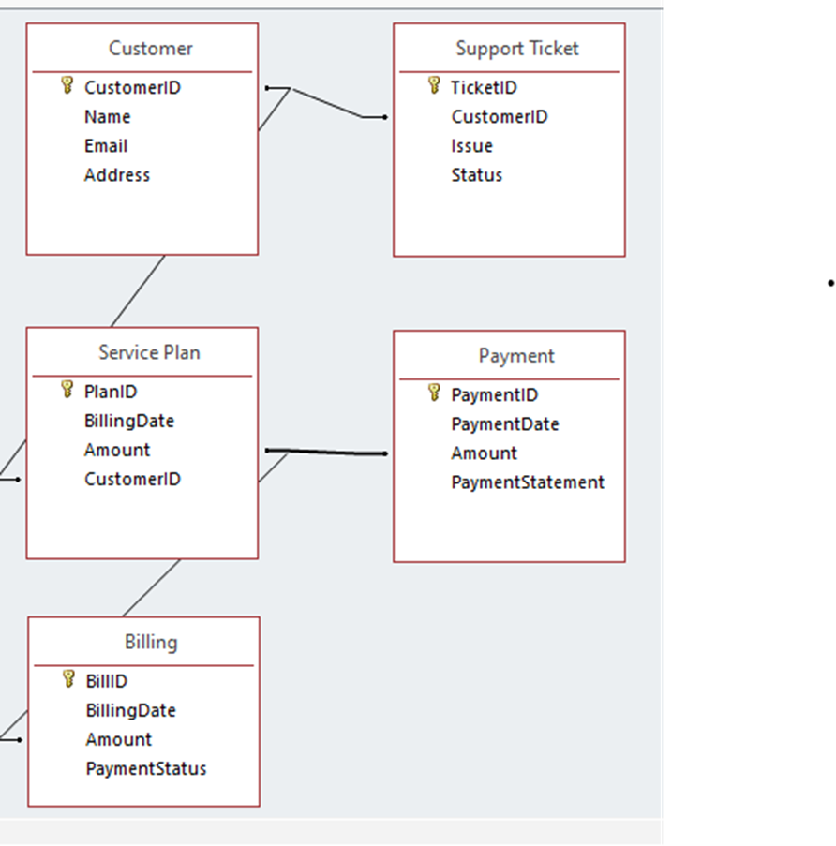

### ****Flowcharts****

Flowcharts are used to represent workflows or specific algorithms within the system for example, the payment process, account creation, or support ticket handling.

INPUT DETAILS

VALIDATION

SAVE TO DATABASE

CONFIRMATION

1. **Data Dictionary**

A Data Dictionary is a detailed description of all the data elements in a system including their names, types, formats, allowed values, andrelationships**.**

|  |  |  |  |  |  |
| --- | --- | --- | --- | --- | --- |
| **Entity** | **Attribute** | **Data Type** | **Format** | **Description** | **Constraints** |
| **Customer** | Customer ID | Integer | Auto-increment | Unique customer identifier | Primary Key, Not Null |
|  | First Name | Varchar | 50 | Customer's first name | Not Null |
| Last Name | Varchar | 50 | Customer's last name | Not Null |
| Email | Varchar | 100 | Customer's email address | Unique, Not Null |
| Phone Number | Varchar | 20 | Customer's phone number | Not Null |
| Password Hash | Varchar | 255 | Encrypted password | Not Null |
| Address | Varchar | 255 | Customer’s residential address | Optional |
| Registration Date | Date Time | - | Date of account creation | Default: Current Timestamp |

* 1. **Logical Design**
     1. **Logical Data Design**

# Benefits of the 3NF Design

* Data is **atomic** and **non-redundant**.
* Easy to **track billing and payment history**.
* Scalable for **multiple service plans**, **multiple tickets**, and **multiple payment types**.
* **Secure customer data** storage structure.

**CUSTOMER**

| **Attribute** | **Type** | **Description** | **Constraints** |
| --- | --- | --- | --- |
| Customer ID | INT (PK) | Unique customer ID | Auto-increment, Primary Key |
| FirstName | VARCHAR (50) | Customer’s first name | NOT NULL |
| Last Name | VARCHAR (50) | Customer’s last name | NOT NULL |
| Email | VARCHAR (100) | Customer’s email address | UNIQUE, NOT NULL |
| Phone Number | VARCHAR (20) | Customer’s phone | NOT NULL |
| Password Hash | VARCHAR (255) | Encrypted password | NOT NULL |
| Address | VARCHAR (255) | Customer’s address | NULL |
| Registration Date | DATETIME | When customer registered | Default: CURRENT_TIMESTAMP |
|  |

**SERVICE PLAN**

| **Attribute** | **Type** | **Description** | **Constraints** |
| --- | --- | --- | --- |
| Plan ID | INT (PK) | Unique service plan ID | Auto-increment, Primary Key |
| Plan Name | VARCHAR (100) | Name of internet plan | NOT NULL |
| Data Limit | INT | Data cap (e.g., GBs) | NULL |
| Monthly Cost | DECIMAL (10,2) | Monthly fee | NOT NULL |
| Speed | VARCHAR (50) | Internet speed (e.g., 50 Mbps) | NOT NULL |

**BILLING**

| **Attribute** |  | **Type** | **Description** | **Constraints** |
| --- | --- | --- | --- | --- |
| Bill ID |  | INT (PK) | Unique bill ID | Auto-increment, Primary Key |
| Customer ID |  | INT (FK) | Related customer | Foreign Key (Customer ID) |
| Billing Date |  | DATE | Date bill is generated | NOT NULL |
| Amount |  | DECIMAL (10,2) | Bill amount | NOT NULL |
| Payment Status |  | ENUM ('Paid', 'Pending', 'Overdue') | Bill status | Default: 'Pending' |

**PAYMENT ID**

| **Attribute** | **Type** | **Description** | **Constraints** |
| --- | --- | --- | --- |
| Payment ID | INT (PK) | Unique payment ID | Auto-increment, Primary Key |
| Bill ID | INT (FK) | Related bill | Foreign Key (Bill ID) |
| Payment Date | DATE | Date payment was made | NOT NULL |
| Amount Paid | DECIMAL (10,2) | Amount paid | NOT NULL |
| Payment Method | ENUM ('Credit Card', 'Mobile Money', 'Bank Transfer') | Payment type | NOT NULL |
| Payment Receipt | VARCHAR (100) | Reference ID or receipt number | NULL |

**SUPPORT TICKET**

| **Attribute** | **Type** | **Description** | **Constraints** |
| --- | --- | --- | --- |
| Ticket ID | INT (PK) | Unique ticket ID | Auto-increment, Primary Key |
| Customer ID | INT (FK) | Related customer | Foreign Key (Customer ID) |
| Issue Description | TEXT | Description of the problem | NOT NULL |
| Status | ENUM ('Open', 'In Progress', 'Closed') | Status of the issue | Default: 'Open' |
| Created At | DATE TIME | When ticket was created | Default: CURRENT_TIMESTAMP |
| Resolved At | DATE TIME | When ticket was resolved | NULL |

* + 1. **Entity Attributes Relationships**

**Customer**: Generated upon registration → able to update information → Deactivate able.  
  
**Billing**: Automatically generated each month; payment is outstanding until it is received.  
  
**Payment**: Created upon customer payment → May be modified in the event that payment is unsuccessful.  
  
When a consumer raises a problem, a **support ticket** is created: From Open to In Progress to Closed, status updates are provided.  
  
**Service Plan**: Admin created it by hand; it is updated whenever plan prices and benefits change.

| **Entity 1** | **Relationship Type** | **Entity 2** |
| --- | --- | --- |
| Customer | 1: N | Billing |
| Customer | 1: N | Support Ticket |
| Billing | 1: N | Payment |
| Service Plan | 1: N | Customer |

* + 1. **Entity life history**

**CUSTOMER Entity Life History**

|  | **Event** | **Action** |
| --- | --- | --- |
| 1 | Customer Registers | Create a new Customer record (Registration Date auto-filled) |
| 2 | Customer Updates Profile | Update Customer attributes (e.g., Address, Phone Number) |
| 3 | Customer Changes Password | Update Password Hash field |
| 4 | Customer Deactivates Account (optional) | Set account to "inactive" or delete record based on business rules |

## SERVICE_PLAN Entity Life History

| **Stage** | **Event** | **Action** |
| --- | --- | --- |
| 1 | Admin Creates New Plan | Create a Service Plan (PlanID auto-generated) |
| 2 | Admin Updates Plan | Update Plan details (e.g., Monthly Cost, Speed) |
| 3 | Admin Deletes/Retires Plan | Remove Plan (only if no customers linked OR archive it) |

**BILLING Entity Life History**

| **Event** | **Action** | |
| --- | --- | --- |
| Bill Generated (Monthly/Usage Based) | Create a Billing record linked to Customer ID | |
| Customer Makes Payment | Update Payment Status to 'Paid' | |
| Payment Overdue | Update Payment Status to 'Overdue' after due date | |
| Billing Error Correction (optional) | Admin adjusts Amount or Billing Date manually |

**PAYMENT Entity Life History**

| **Stage** | **Event** | **Action** |
| --- | --- | --- |
| 1 | Payment Initiated | Create a Payment linked to a Bill |
| 2 | Payment Confirmed | Confirm and save Payment Date, Amount Paid, and Payment Method |
| 3 | Payment Failure (optional) | Flag Payment as Failed; retry or notify Customer |
| 4 | Payment Dispute/Refund (optional) | Admin initiates a refund or cancels Payment |

**SUPPORT_TICKET Entity Life History**

| **Stage** | **Event** | **Action** | |
| --- | --- | --- | --- |
| 1 | Ticket Created | Customer reports an issue (Ticket status = 'Open') | |
| 2 | Ticket Assigned | | Technician or Support Staff takes the ticket |
| 3 | Ticket in Progress | | Status changes to 'In Progress' while issue being handled |
| 4 | Ticket Resolved | | Status changed to 'Closed' and Resolved At timestamp set |
| 5 | Ticket Reopened (optional) | | Customer reopens if issue reoccurs before final closure |
|  | | | | |
|  | | | | |
|  | | | | |

* 1. **PHYSICAL DESIGN DESCRPITION**
     1. **DATA DICTIONARY**

A **Data Dictionary** is a **detailed list or reference table** that describes all the **data elements** (fields) in a **database** or **system**.

| **Table Name** | **Field Name** | **Data Type** | **Description** |
| --- | --- | --- | --- |
| Customer | Customer ID | INT | Unique ID for each customer (Primary Key) |
|  | FirstName | VARCHAR (50) | Customer’s first name |
|  | Last Name | VARCHAR (50) | Customer’s last name |
|  | Email | VARCHAR (100) | Email address (must be unique) |
|  | Phone Number | VARCHAR (20) | Contact number |
|  | Password Hash | VARCHAR (255) | Encrypted password |
|  | Address | VARCHAR (255) | Residential address |

* + 1. **FILE/DATABASE DESIGN**

This is the process of planning and creating the structure of a database or file system before you start building it.

It answers how your data will be organized, stored, linked, and retrieved.

**Customer Table**

CREATE TABLE Customer (

Customer ID INT AUTO_INCREMENT PRIMARY KEY,

FirstName VARCHAR (50) NOT NULL,

Last Name VARCHAR (50) NOT NULL,

Email VARCHAR (100) NOT NULL UNIQUE,

Phone Number VARCHAR (20) NOT NULL,

Password Hash VARCHAR (255) NOT NULL,

Address VARCHAR (255),

Registration Date DATETIME DEFAULT CURRENT_TIMESTAMP

);

**Service Plan Table**

CREATE TABLE Service Plan (

Plan ID INT AUTO_INCREMENT PRIMARY KEY,

Plan Name VARCHAR (100) NOT NULL,

Data Limit INT,

Monthly Cost DECIMAL (10,2) NOT NULL,

Speed VARCHAR (50) NOT NULL

);

**Billing Table**

CREATE TABLE Billing (

Bill ID INT AUTO_INCREMENT PRIMARY KEY,

Customer ID INT NOT NULL,

Billing Date DATE NOT NULL,

Amount DECIMAL (10,2) NOT NULL,

Payment Status ENUM ('Paid', 'Pending', 'Overdue') DEFAULT 'Pending',

FOREIGN KEY (Customer ID) REFERENCES Customer (Customer ID)

);

**Payment Table**

CREATE TABLE Payment (

Payment ID INT AUTO_INCREMENT PRIMARY KEY,

Bill ID INT NOT NULL,

Payment Date DATE NOT NULL,

Amount Paid DECIMAL (10,2) NOT NULL,

Payment Method ENUM ('Mobile Money', 'Bank Transfer', 'Card') NOT NULL,

Payment Receipt VARCHAR (100),

FOREIGN KEY (Bill ID) REFERENCES Billing (Bill ID)

);

**Support Ticket Table**

CREATE TABLE Support Ticket (

Ticket ID INT AUTO_INCREMENT PRIMARY KEY,

Customer ID INT NOT NULL,

Issue Description TEXT NOT NULL,

Status ENUM ('Open', 'In Progress', 'Closed') DEFAULT 'Open',

Created at DATETIME DEFAULT CURRENT_TIMESTAMP,

Resolved At DATETIME,

FOREIGN KEY (Customer ID) REFERENCES Customer (Customer ID)

);

* + 1. **INPUT SCREEN DESIGN**

This shows how the user (admin, customer, staff) will enter the information into the system field by field in a **clear and user-friendly form layout**.

1. **Sign Up screen**

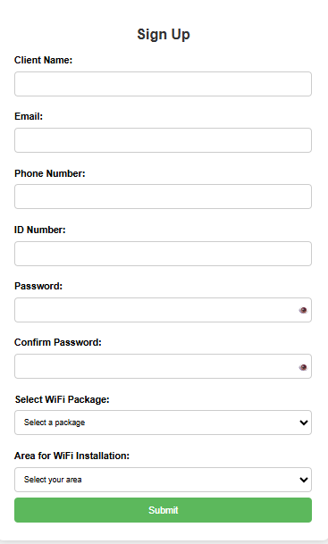

1. **Login Screen**

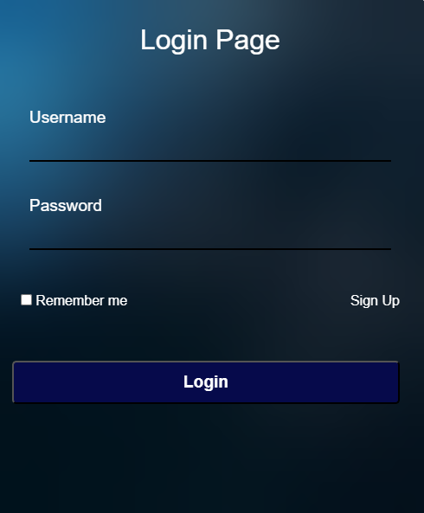

1. **Payment Screen**

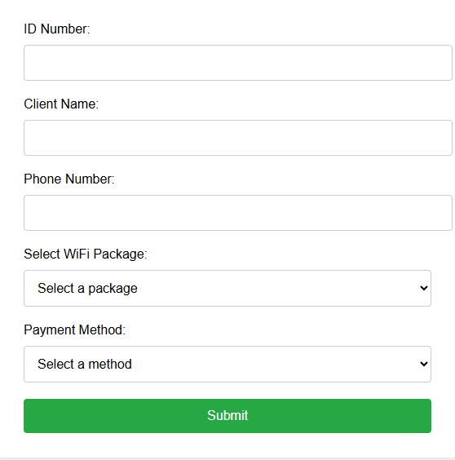

1. **Support Screen**

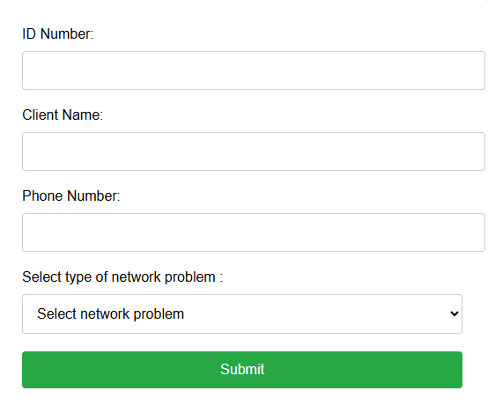

* + 1. **OUTPUT SCREEN DESIGN**

### ****Registered Customers Report Screen****

**Title:** Registered Customers

| **Customer ID** | **Full Name** | **Email Address** | **Phone Number** | **Address** | **Registration Date** |
| --- | --- | --- | --- | --- | --- |
| 1001 | Jane Doe | jane.doe@example.com | 0712345678 | Nairobi | 2025-03-01 |
| 1002 | John Kamau | john.k@example.com | 0723456789 | Kiambu | 2025-03-04 |

### ****Service Plans Report Screen****

**Title:** Service Plans

| **Plan ID** | **Plan Name** | **Data Limit (GB)** | **Speed** | **Monthly Cost** |
| --- | --- | --- | --- | --- |
| 1 | Basic Plan | 50 | 10 Mbps | KSh 1,500 |
| 2 | Premium Plan | 200 | 50 Mbps | KSh 7.500 |

### ****Billing and Invoices Report Screen****

**Title:** Billing History

| **Bill ID** | **Customer Name** | **Billing Date** | **Amount (KSh)** | **Payment Status** |
| --- | --- | --- | --- | --- |
| 3001 | Jane Doe | 2025-04-01 | 1,500 | Paid |
| 3002 | John Kamau | 2025-04-01 | 7,500 | Overdue |

### ****Support Tickets Report Screen****

**Title:** Support Tickets

| **Ticket ID** | **Customer Name** | **Issue Summary** | **Status** | **Created At** | **Resolved At** |
| --- | --- | --- | --- | --- | --- |
| 5001 | Jane Doe | App Not Loading | Closed | 2025-04-05 | 2025-04-06 |
| 5002 | John Kamau | Connectivity issue | In Progress | 2025-04-07 | — |

### ****Payment Transactions Report Screen****

**Title:** Payment History

| **Payment ID** | **Bill ID** | **Customer Name** | **Payment Date** | **Amount Paid** | **Method** | **Receipt No.** |
| --- | --- | --- | --- | --- | --- | --- |
| 4001 | 3001 | Jane Doe | 2025-04-02 | 1,500 | Mobile Money | MPESA1234 |
| 4002 | 3002 | John Kamau | 2025-04-04 | 7,500 | Bank Transfer | BANK5678 |

* + 1. **CODE DESIGN**

This refers to how **primary keys** and **foreign keys** are structured and enforced in your system.

These **record keys** are critical for uniquely identifying and linking data across tables.

| **Table Name** | **Primary Key** | | | **Format** | | **Generation Method** | | | **Reason** |
| --- | --- | --- | --- | --- | --- | --- | --- | --- | --- |
| Customer | CustomerID | | | Auto-incremented integer (e.g., 1001) | | Auto-generated by the database | | | Uniquely identifies each customer for linking to billing, payments, etc. |
| Service Plan | PlanID | | | Auto-incremented integer (e.g., 1) | | Auto-generated by the database | | | Distinguishes different service packages for selection and billing. |
| Billing | BillID | | | Auto-incremented integer (e.g., 5001) | | System-generated at billing time | | | Tracks individual billing records per customer for audits and tracking. |
| Payment | PaymentID | | | Auto-incremented integer (e.g., 7001) | | System-generated at payment confirmation | | | Records customer payments and links to billing for financial tracking. |
| Support Ticket | | TicketID | Auto-incremented integer (e.g., T1001) | |  | | Auto-generated at ticket submission | Tracks service issues and resolutions raised by customers. | |

* + 1. BLOCK DIAGRAM/MODULAR CHART

A **Block Diagram** or **Modular Chart** is a visual representation of a system, broken down into its key components or "modules."

It shows **how the system is organized**, and how the **different parts (modules)** interact with each other.

SQITECH WEB SYSTEM

Customer Module

Billing Module

Support Module

Raise Tickets

Ticket Tracking

Live Chat

Generate Invoices

View Payment status

Record Payments

Registration

Profile Update

Service Plans

Admin Management

System Settings

Analytics/Logs

User Management

Network Monitor

4.5.7 **UML Diagram**



**CHAPTER FIVE: SYSTEM IMPLEMENTATION AND TESTING**

### Overview

This chapter consists of; Tools used in development, the platform used, changeover technique, implementation plan and methods used, test plan, test data with records.

### Tools Used in the Development

The development of the Sqitech Internet Service Provider system involved several tools that facilitated both frontend and backend implementation. These tools were chosen based on their reliability, ease of use, community support, and compatibility with web-based systems. Below are the key tools utilized:

|  |  |
| --- | --- |
| **TOOLS** | **DESCRIPTION** |
| Visual Studio Code (VS Code) | Used as the main code editor for writing and managing HTML, CSS, PHP, and JavaScript files. |
| XAMPP | Provided a local server environment (Apache) and MySQL database for backend development and testing. |
| PHP | Used as the server-side scripting language to handle form submissions, process data, and interact with the MySQL database. |
| MySQL | Served as the database management system to store customer details, payment details, and more. |
| phpMyAdmin | A web-based interface for managing the MySQL database, creating tables, and performing database operations. |
| HTML & CSS | Used to structure and style the frontend pages of the Sqitech Internet Service Provider platform |
| Web Browser | Used for testing and viewing the web application during development. |

These tools together enabled the development team to design, implement, test, and run the system in a controlled local environment before full deployment.

### The Platform Used

The Sqitech Iinternet Service Provider system was developed and tested on a local development platform that simulates a real web server environment. This platform ensures that all components of the system function as expected before deployment. The platform used includes:

| **PLATFORM COMPONENT** | **DETAILS** |
| --- | --- |
| **Operating System** | Windows 10 – Used to run the entire development environment and host local servers. |
| **XAMPP** | A cross-platform package that integrates Apache (web server), MySQL (database), and PHP (server-side scripting). It provides a local environment for testing and running PHP-based applications. |
| **Web Browser** | Google Chrome – Used for testing and debugging the frontend of the application. It offers developer tools for inspecting HTML/CSS and testing responsive design. |
| **Text Editor** | Visual Studio Code – A powerful, lightweight code editor used for writing and managing project files including HTML, CSS, PHP, and JavaScript. |
| **phpMyAdmin** | A web-based MySQL administration tool used for creating and managing the system’s database and its tables through a GUI. |

These platforms were chosen for their simplicity, ease of integration, and wide support within the web development community. They allowed for efficient testing, debugging, and refinement of the system before any future live deployment.

### Proposed Changeover

The changeover technique selected for implementing the Sqitech internet Service Provider system is the **Parallel Changeover** method. In this approach, both the existing manual processes and the new web-based system are run concurrently for a specific period. During this time, users continue to operate the manual system while simultaneously testing and familiarizing themselves with the new online platform.

#### ****Reasons for Choosing the Parallel Changeover Technique**:**

|  |  |
| --- | --- |

1. Running both systems in parallel ensures that if any issues arise in the new system, the manual method can serve as a reliable backup.
2. The results from the new system can be cross-checked against those from the manual system, helping validate accuracy and reliability.

|  |  |
| --- | --- |

1. Running both systems in parallel ensures that if any issues arise in the new system, the manual method can serve as a reliable backup.
2. The results from the new system can be cross-checked against those from the manual system, helping validate accuracy and reliability.
3. Users are given enough time to adapt to the new system gradually, reducing resistance to change and increasing confidence.
4. While the systems run in parallel, users can receive training and support in real-time without disrupting ongoing operations.
5. It provides a smooth and controlled transition, especially important for critical systems where data integrity is essential.

### Implementation Plan

The implementation of the Sqitech internet Service Provider system follows a systematic approach to ensure a smooth transition from the manual to the automated system. This plan outlines the steps and strategies for deploying the system, training users, and ensuring the system functions correctly in the real environment.

|  |  |  |
| --- | --- | --- |
| **STEPS** | **ACTIVITY** | **DESCRIPTION** |
| 1 | Preparation and environment setup | Install XAMPP and set up the Apache server and MySQL database. Ensure VS Code is configured properly. Create required database tables and test connectivity. |
| 2 | Frontend Integration | Integrate the existing HTML and CSS frontend with PHP to handle dynamic content such as customer registration, and login. |
| 3 | Database Connection | Connect all user forms to the MySQL database using PHP. Validate and test form submissions. |
| 4 | User testing and debugging | Allow selected users to test the system. Collect feedback and fix bugs or errors encountered during use. |
| 5 | Training | Offer training sessions for company staff and administrators on how to use the system effectively. |
| 6 | Parallel Operations | Run both manual and online systems concurrently to ensure reliability and build user confidence. |
| 7 | Full Deployment | After successful testing and parallel run, fully transition to the online system. Monitor performance and user activity. |
| 8 | Maintenance and updates | Regularly update system features, patch bugs, and provide user support for continued effectiveness. |

This implementation plan ensures a gradual, risk-controlled rollout of the Sqitech Internet Service Provider system with user involvement and real-world validation at every step.

### Methods Used

Testing is an essential phase in the development of the Sqitech Internet Service Provider system to ensure the system performs correctly, meets user requirements, and handles data accurately. This section outlines the **testing strategy, test plan, sample test data,** and **records of results.**

To ensure that the Sqitech Internet Service Provider system functioned correctly and met user requirements, several testing methods were employed throughout the development process:

#### **1. System Testing**

System testing was conducted to evaluate the complete and integrated software system. This helped ensure that all components from Sign Up and login to payment and support worked together seamlessly in the intended environment.

#### **2. Program Testing**

Program testing focused on individual modules or components of the system. For example, the login module and sign up module were tested independently to verify that each program or script executed as expected.

#### **3. Unit Testing**

Unit testing involved testing individual units or functions of the system in isolation. Each PHP function, such as database connection or data insertion, was tested to confirm that it performed its task correctly before integration.

#### **4. Integration Testing**

Integration testing was done to verify the interaction between different modules. This ensured data consistency and smooth communication between modules.

#### **5. Acceptance Testing**

Finally, acceptance testing was carried out to confirm that the system met all user requirements and was ready for deployment. The system was presented to a sample user group to test whether the functionality met their expectations and whether the interface was user-friendly.